Social Media Content and Images - Statistics

Image files are available for download by clicking here.

2019 Statistics

Please take a moment on April 28 to remember the 140 B.C. workers who died last year from a workplace injury or disease. www.dayofmourning.bc.ca #DayOfMourning

Image: 2020DoM_DYK_OD
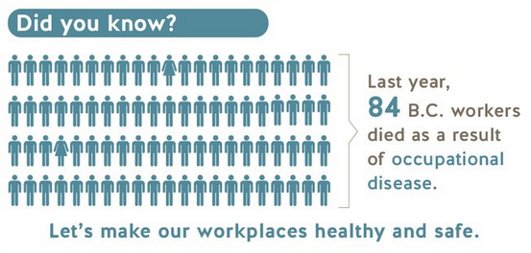

Please take a moment on April 28 to remember the 140 B.C. workers who died last year from a workplace injury or disease. www.dayofmourning.bc.ca #DayOfMourning

Image: 2020DoM_DYK_ASB
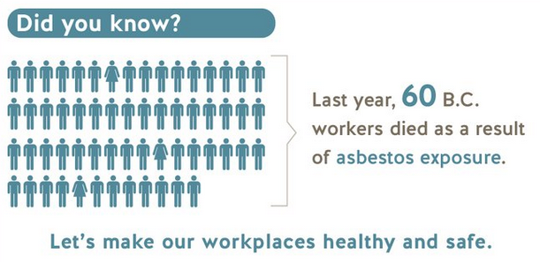

Image: 2020DoM_DYK_HiRisk
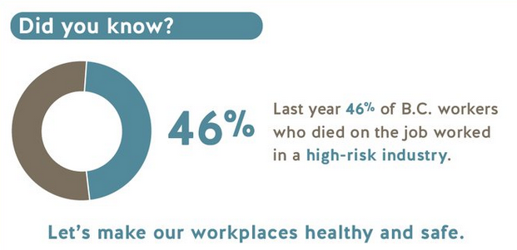

One workplace death is too many. On April 28, please take a moment to remember the 140 B.C. workers who died last year from a workplace injury or disease. www.dayofmourning.bc.ca #DayOfMourning

Image: 2020DoM_DYK_140stat
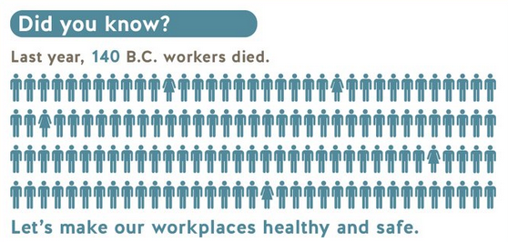

One workplace death is too many. On April 28, please take a moment to remember the 140 B.C. workers who died last year from a workplace injury or disease. www.dayofmourning.bc.ca #DayOfMourning

Image: 2020DoM_DYK_forestry
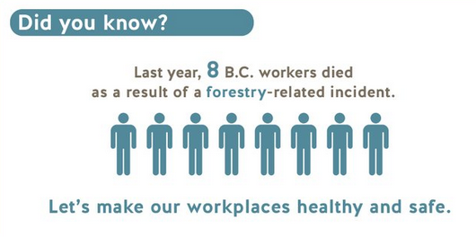

Work-related injuries and disease are preventable and not a part of the job, nor a cost of doing business. On April 28, please take a moment to remember the 140 B.C. workers who died last year from a workplace injury or disease. www.dayofmourning.bc.ca #DayOfMourning

Image: 2020DoM_DYK_140stat
Workplace injuries and illnesses claimed the lives of 140 workers last year. On April 28, please take a moment to remember the 140 B.C. workers who died last year from a workplace injury or disease. www.dayofmourning.bc.ca #DayOfMourning

Image: 2020DoM_DYK_CONST
