Social Media Content and Images

Image files are available for download by clicking here

Online event – sample posts

Join us online on April 28 @ 10:30am for a moment of silence to remember the 140 B.C. workers who died last year from a workplace injury or disease. #DayOfMourning www.dayofmourning.bc.ca

In lieu of a physical ceremony, please join us online on April 28 @ 10:30am for a moment of silence to remember the 140 B.C. workers who died last year. #DayOfMourning www.dayofmourning.bc.ca

Join us in a moment of silence online on April 28 at 10:30 am to remember the 140 B.C. workers who died last year from a workplace injury or disease. Watch a video from our partners recognizing the day and those we lost. #DayOfMourning www.dayofmourning.bc.ca

Image: DoM_ribbon-TW1024x512-apr20.jpg

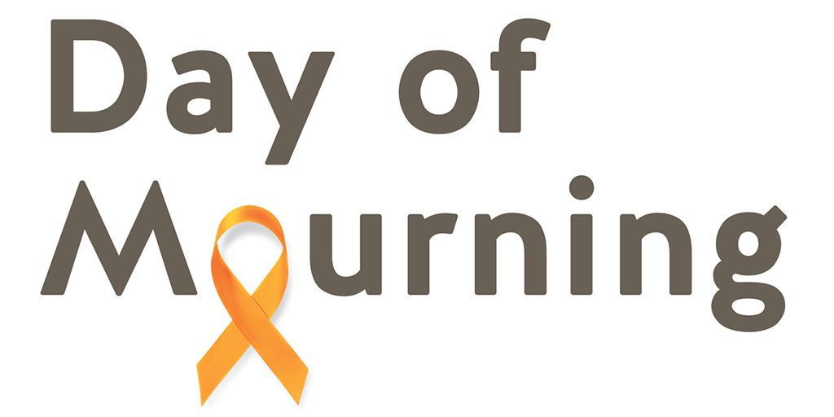

Image: DoM_ribbon-TW1024x512-apr20.jpg

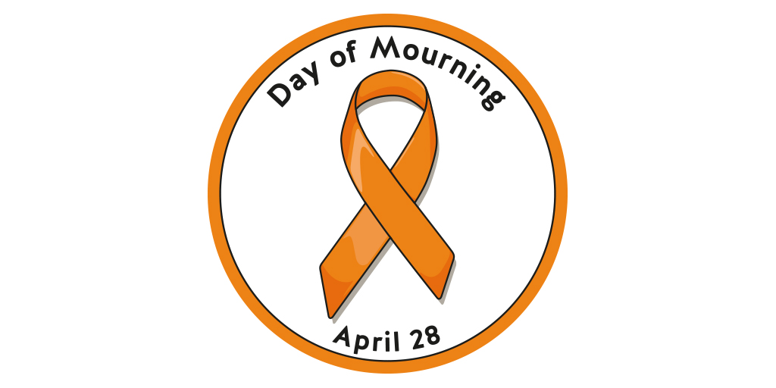

Family stories – sample posts

Image files are available for download by clicking here

Sadaf Abdul

When you lose a loved one, the pain never goes away. When Sadaf Abdul was just 14 years old she lost her father to a workplace injury. Here is her story: https://www.dayofmourning.bc.ca/speaker/sadaf-abdul/ #DayOfMourning

Image: SadafAbdul-TW1024x512-apr20.jpg

Phil Huxley

Phil Huxley’s son Ryan was working in a nursery driving an ATV when it crashed into a parked semi-trailer. Ryan didn’t survive his injuries. https://www.dayofmourning.bc.ca/speaker/phillip-huxley/ #DayOfMourning

Image: PhilHuxley_TW1024x512_apr20.jpg

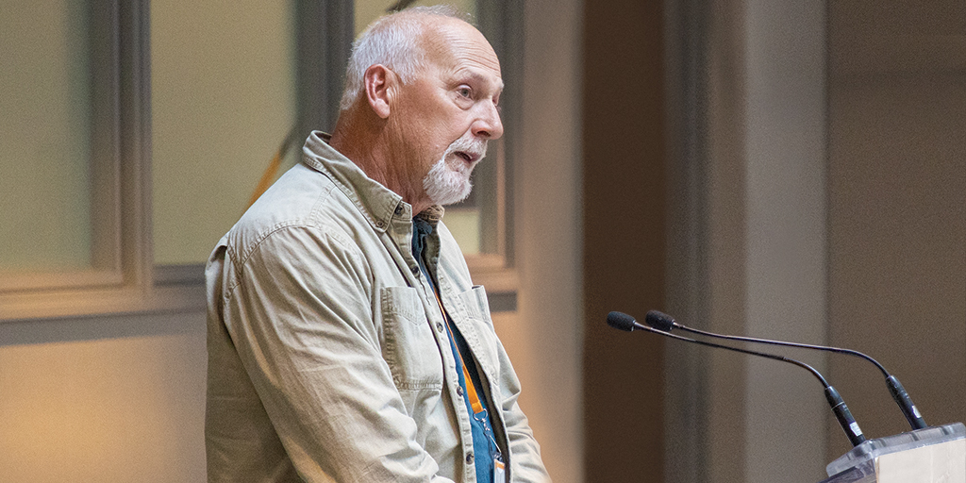

Jessica Kruger

Jessica Kruger broke her neck in a workplace accident. She shares her experience to commemorate #DayOfMourning and those who died in the workplace.

Image: JessicaKruger-TW1024x512-apr20.jpg

