Social Media Content and Images

February 24 – April 17

How can you participate in Day of Mourning? Honour lives lost in the workplace by downloading posters and decals and sharing them with your co-workers: http://www.dayofmourning.bc.ca/decals/ #DayOfMourning

February 24 – April 24

Day of Mourning is April 28. Here’s how to plan your own workplace event using our toolkit: https://www.dayofmourning.bc.ca/get-started/ #DayOfMourning

March 9 – April 28

#DayOfMourning is taking place across B.C. on Tuesday, April 28. Join us as we reflect on those we’ve lost, and renew our commitment to creating healthy and safe workplaces for everyone. Find a ceremony near you: https://www.dayofmourning.bc.ca/

To leave a note in honour of a fallen family member, friend or co-worker please click here: https://www.dayofmourning.bc.ca/dedication-landing #DayOfMourning

This year’s #DayOfMourning in #Vancouver will take place at Jack Poole Plaza on April 28th at 10:45am: https://www.dayofmourning.bc.ca/

510 x 510

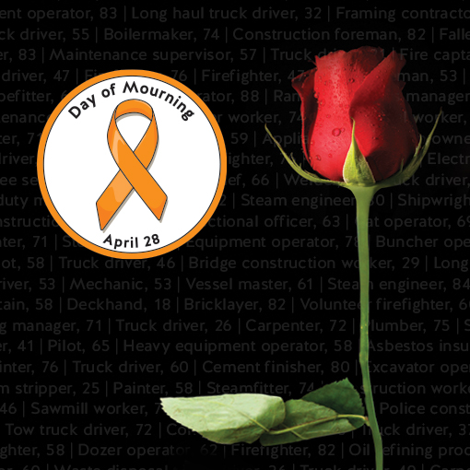

640 x 640

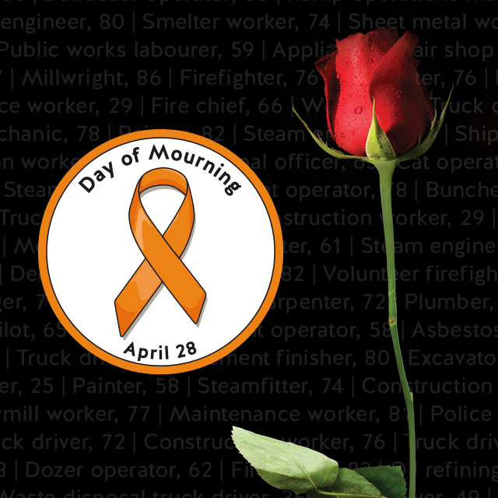

1024 x 512

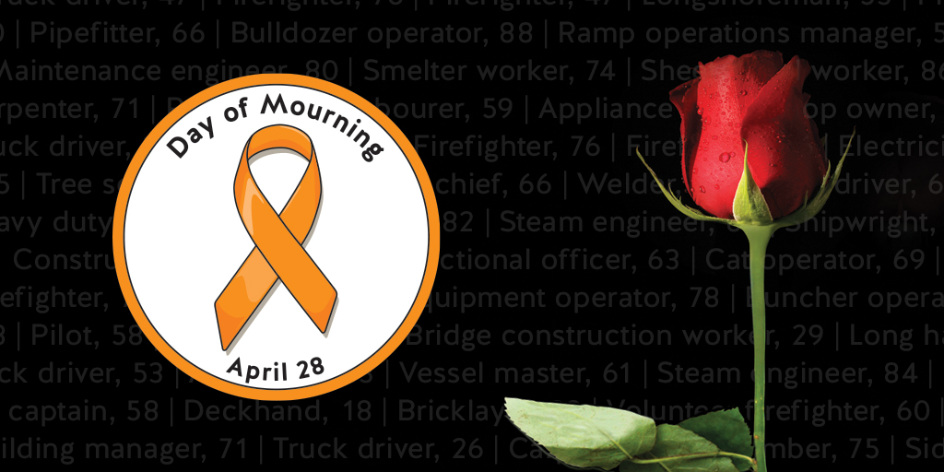

1200 x 627

