Thank you for using the day of mourning advertisement. Feel free to include your own organization and approved partner logos. However, the WorkSafeBC logo is restricted to official partnerships and therefore cannot be included.
This ad is a full colour 4.5” x 4.5”. The boundaries of the ad are the grey box.
Editable information (eg., date, time, and location of ceremony) is in the text box.

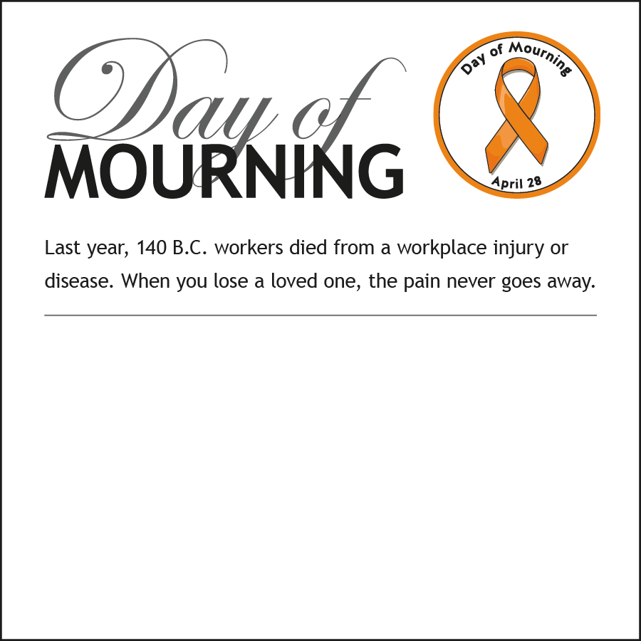
Place information regarding the ceremony here. Logos can be placed at the bottom of the ad (within the borders).

